A

Project Report on

# Strategies and Tools for Fake Message Detection in Digital World

A Report Submitted in partial fulfillment of the requirements for the award of the Degree of Bachelor of Technology

By

## B. Dinesh Kumar

(20EG105604)

## 



Under the guidance of

**Dr. N. Swapna Goud** Assistant Professor Department of CSE

## DEPARTMENT OF COMPUTER SCIENCE AND ENGINEERING ANURAG UNIVERSITY

**VENTAKAPUR (V)**

**TELANGANA**

**(2023-2024)**

# DECLARATION

We hereby declare that the Report entitled **Strategies and Tools for Fake Message Detection in Digital World** submitted for the award of Bachelor of technology Degree is our original work and the Report has not formed the basis for the award of any degree, diploma, associateship or f ellowship of similar other titles. It has not been submitted to any other University or Institution for the award of any degree or diploma.

Place: HyderabadB. Dinesh Kumar

Date: 20 April 2024 (20EG105604)



# CERTIFICATE

This is to certify that the project report entitled **Strategies and Tools for Fake Message Detection in Digital World** that is being submitted by **B. Dinesh Kumar** bearing the hall ticket number **20EG105604,** in partial fulfillment of for the award of B.Tech in Computer Science and Engineering to Anurag University is a record of bonafide work carried out by them under my guidance and supervision.

The results embodied in this report have not been submitted to any other University for the award of any other degree or diploma.

|  |  |
| --- | --- |
| Dr. N. Swapna Goud Assistant Professor  Department of CSE | Dr. G. Vishnu Murthy  Dean, CSE |

External Examiner

# ACKNOWLEDGMENT

We would like to express our sincere thanks and deep sense of gratitude to project supervisor **Dr. N. Swapna Goud , Assistant Professor, Department of CSE** for her constant encouragement and inspiring guidance without which this project could not have been completed. Her critical reviews and constructive comments improved our grasp of the subject and steered to the fruitful completion of the work. Her patience, guidance and encouragement made this project possible.

We would like to express my special thanks to **Dr. V. Vijaya Kumar, Dean School of Engineering, Anurag University,** for his encouragement and timely support in our B. Tech program.

We would like to acknowledge our sincere gratitude for the support extended by **Dr. G. Vishnu Murthy, Dean, Dept. of CSE, Anurag University.** We also express my deep sense of gratitude to **Dr. V V S S S Balaram, Academic co-ordinator, Anurag University** and **Dr. Pallam Ravi, Project in-Charge. Dr. A. Jyothi** Project Co-ordinator and Project review committee members, whose research expertise and commitment to the highest standards continuously motivated us during the crucial stage our project work.

B. Dinesh Kumar (20EG105604)

# ABSTRACT

Social media network is one of the important parts of human life based on the recent technologies and developments in terms of computer science area. This environment has become a famous platform for sharing information and news on any topics and daily reports, which is the main era for collecting data and data transmission. There are various advantages of this environment, but in another point of view there are lots of fake news and information that mislead the reader and user for the information needed. Lack of trust-able information and real news of social media information is one of the huge problems of this system. To overcome this problem, proposed an integrated system for various aspects of cloud computing and passive-aggressive learning techniques to detect fake news and better predict fake user accounts and posts. The Reinforcement Learning technique is applied for this process. Improved this platform in terms of security, the decentralized blockchain framework applied, which provides the outline of digital contents authority proof. More specifically, the concept of this system is developing a secure platform to predict and identify fake news in social media networks.

**TABLE OF CONTENTS**

|  |  |  |
| --- | --- | --- |
| **S. No.** | **CONTENT** | **Page No.** |
| 1. | Introduction | 1 |
| 2. | Literature Survey | 5 |
| 3.  4.  5.  6.  7.  8.    9.  10.  11.  12. | Working Methodology  System Analysis  4.1. Existing System  4.1.1 Disadvantages of Existing System  4.2 Proposed System  4.2.1 Advantages of Proposed System  System Design  5.1 Introduction  5.2 Modules  5.3 Methodology  5.4 Testing and Training  5.5 System Architecture  5.5.1 Construction of Use case diagrams  5.5.2 Sequence Diagrams  5.5.3 Class Diagram  5.5.4 Activity Diagram  Implementation  6.1 System Requirements  6.2 Input and Output Design  6.2.1 Logical Design  6.2.2 Physical Design  6.3 Input and Output Representation  6.3.1 Input Design  6.3.2 Objectives  6.3.2 Output Design  Sample Code  System Testing  8.1 Introduction  8.2 Levels of Testing  Declaration of Results  Conclusion  Future Scope  References | 8  10  10  10  10  11  12  12  12  12  13  15  19  20  21  22  23  23  24  24  24  25  23  24  26  27  38  38  38  50  51  52  54 |
|  |  |  |
|  |  |  |
|  |  |  |
|  |  |  |
|  |  |  |
|  |  |  |

**List of Figures**

|  |  |  |
| --- | --- | --- |
| **Figure No.** | **Figure Name** | **Page No.** |
| 5.1 | System Architecture | 13 |
| 5.2 | Use case Diagram | 17 |
| 5.3 | Sequence Diagram | 18 |
| 5.4 | Class Diagram | 19 |
| 5.5 | Activity Diagram | 20 |

**List of Abbreviations**

|  |  |
| --- | --- |
| **Abbreviations** | **Full Form** |
| NLP | Natural Language Processing |
| AI | Artificial Intelligence |
| ML | Machine Learning |
| API | Application Programming Interface |
| LSTM | Long Short-Term Memory |
| QOT | Quality of Trust |
| GPT | Generative Pre-trained Transformer |
| TF-IDF | Term Frequency-Inverse Document  Frequency |
| ROC | Receiver Operating Characteristic |
| AUC | Area Under the Curve |

# Introduction

Variety of shared information is the realistic part of social media. From 2017, fake news has become a very considerable topic until now, which 365% frequently used online. Struggling with fake news becomes an unsolved problem in social networks in the data and information consumption application layer and becomes a serious and challenging issue in information advancement that appears in diplomatic, economic, and political sectors. The fake information revelation points to the unnecessary process in the network resources. Moreover, it contains the content totality and validity based on the available service. Therefore, the wrong information sharing relevance the Quality of Trust (QOT) to apply on the news distribution.

Machine learning text classification improves the level of security that is needed in social media daily-based networking. Expressing feelings or sharing an opinion through the social networking portal from the non-government organization’s survey contains many fake accounts and information circulating the portal based on a suitable channel. In this case, the harmful and unwanted accounts need to pass from the network to give more space to the data center and manage the mess and political problems in the network.

Another related area for information extraction is propaganda which is special for political purposes. The fake news forging language is very crafty in terms of pre-designate to arouse and aggravate the emotion of users for spreading fake information. Fake news detection is the capability of contents analysis based on truth in the shared information. Along with the number of noisy and unstructured data, growth of the number of users, and news, there is a need for an automatic solution for extraction of fake news. These terms become limited based on the recent developments in machine learning, deep learning, and artificial intelligence. Proofing the digital contents authorship is one of the mandatory steps for information sharing.

To do this, cloud computing is a suitable and promising framework that is the decentralized and secure platform to improve fake information extraction. A cloud computing system continuously increases the number of blocks which each block has previous block cryptographic hash, timestamp and transactions information.

In today's digital age, the spread of misinformation and fake news poses a significant challenge to society. With the rise of social media and online platforms, anyone can create and disseminate information with ease, often without accountability or accuracy. This proliferation of fake news can have far-reaching consequences, from influencing public opinion to undermining trust in institutions and jeopardizing democratic processes.

To combat this growing problem, researchers and technologists have turned to innovative solutions, one of which is leveraging cloud computing for fake news detection. Cloud computing offers a scalable, flexible, and cost-effective platform for analyzing vast amounts of data in real-time, making it an ideal infrastructure for detecting and combating fake news.

At its core, fake news detection using cloud computing involves harnessing the power of distributed computing resources to process and analyze diverse sources of information, including text, images, and videos. By employing advanced machine learning algorithms, natural language processing techniques, and data analytics tools, researchers can sift through enormous datasets to identify patterns, anomalies, and indicators of misinformation.

One of the key advantages of using cloud computing for fake news detection is its scalability. Cloud platforms such as Amazon Web Services (AWS), Google Cloud Platform (GCP), and Microsoft Azure offer virtually unlimited computing resources on-demand, allowing researchers to scale their detection algorithms to handle large volumes of data efficiently. This scalability is essential given the sheer volume of content generated online every day, spanning social media posts, news articles, blog posts, and more.

Moreover, cloud computing enables real-time processing and analysis of data, ensuring that fake news detection systems can keep pace with the rapid dissemination of misinformation online. By leveraging cloud-based streaming analytics services, researchers can monitor social media feeds, news websites, and other online sources in real-time, flagging suspicious content as it emerges and providing timely alerts to users and authorities.

Another benefit of utilizing cloud computing for fake news detection is its cost-effectiveness. Cloud providers offer pay-as-you-go pricing models, allowing organizations to pay only for the resources they consume without the need for upfront investment in hardware or infrastructure. This makes it feasible for researchers with limited budgets to access state-of-the-art computing resources and develop sophisticated detection algorithms without breaking the bank.

Furthermore, cloud computing facilitates collaboration and knowledge sharing among researchers and organizations working on fake news detection. Cloud-based platforms provide tools for data sharing, collaboration, and version control, enabling researchers from different disciplines and institutions to collaborate on projects, share insights, and leverage each other's expertise to improve detection accuracy and effectiveness.

However, despite its many advantages, fake news detection using cloud computing also presents several challenges and considerations. One of the primary concerns is the ethical and privacy implications of analyzing large datasets containing personal information and user-generated content. Researchers must ensure compliance with data protection regulations and implement robust security measures to safeguard sensitive information and preserve user privacy.

Moreover, the effectiveness of fake news detection algorithms relies heavily on the quality and diversity of training data. Biases in training datasets can lead to algorithmic biases and inaccurate predictions, highlighting the importance of using representative and balanced datasets for model training. Additionally, the dynamic nature of fake news requires continuous monitoring and updating of detection algorithms to adapt to evolving tactics and trends used by malicious actors.

In conclusion, fake news detection using cloud computing holds great promise as a scalable, real-time, and cost-effective solution for combating the spread of misinformation online. By leveraging advanced technologies and distributed computing resources, researchers can develop more robust and effective detection algorithms capable of identifying fake news with greater accuracy and efficiency.

However, addressing the ethical, privacy, and bias concerns associated with fake news detection remains critical to ensure the responsible and ethical use of these technologies in safeguarding the integrity of online information ecosystems.

As a case study, we collected the social media contents from Facebook and Twitter, which are famous information sharing platforms with thousands of users that upload millions of daily news and posts on various topics. This research aims to authorize fake users and information using the blockchain, NLP, and machine learning techniques. More specifically, the proposed system is the preventative approach based on the integrated techniques for the concept of fake data extraction combining with gamification components.

Reinforcement learning is the learning-based algorithm that improves the system quality based on the provided information. If the information is wrong, the system prevents using similar information as before to reduce the fake and wrong information rating. The main contribution of this paper is threefold:

• Designing the fake news prevention system instead of a detection system and applying the Natural Language Processing (NLP) for the detailed text analysis based on the shared contents.

• Applying the proof of authority protocol and designing financial roots. This process is the strong aspect of this system to find fake user information and accounts.

• Applying the Reinforcement Learning technique for predicting the learning rate of the system and extracting fake accounts. Finding the relationship between contents, extracting the similar meaning and structure of the shared information to avoid sharing fake news.

The applied blockchain system is permissioned network that every participants are supposed to register and required authentication to make them qualified to join to blockchain network. In permissioned blockchain only authenticate users have allowance of joining to network which this process is the responsibility of user identification manager. This process also required the authentication certificate and enrollment for the valid participants. The aim of the proposed system is to store the news data in the distributed ledger which is reliable and secure platform.

# 2. Literature Survey

In recent years, the proliferation of technology and the widespread use of applications in daily life have led to the posting and sharing of content without meaningful context on various social media platforms. This trend has caused confusion and difficulty in finding relevant and reliable information. Twitter, among other platforms, faces this challenge due to its large user base, who collectively generate millions of tweets daily. To address the issue of fake news sharing, machine learning (ML) algorithms and cloud computing systems have emerged as crucial tools.

ML algorithms, particularly those leveraging Natural Language Processing (NLP), play a vital role in identifying linguistic patterns indicative of fake or real news. Classifier models are commonly employed in ML processes to distinguish between fake and real information.

Vladimir P Miletskiy utilized Random Forest and NLP to detect fake news by analyzing word frequencies. They also employed the RID matrix approach to identify similarities and copied sources between documents.[1]

Nicollas conducted a survey on fake news detection using deep learning and NLP, exploring various deep learning methods and text classification techniques. Wang et al. proposed a framework for fake news detection that combines a fake news detector, reinforcement learning, and annotator components to extract high-quality samples and identify fake news.[2]

In addition to ML techniques, cloud platforms have been introduced for fake news detection. Sestrem et al. presented a centralized blockchain platform designed to identify fake news through data mining and consensus algorithms. This platform aims to alert readers to fake news, punish those who spread misinformation, and reward truth-tellers. Other studies, such as those by Zonyin et al, Shovon et al. Qayyum et al, Arian et al , Islam et al , and Arquam et al , have explored various blockchain-based approaches to fake news detection, including news authentication, news tracking, news broadcasting, and credit allocation to users based on trustworthiness.[3]

NLP plays a crucial role in understanding and analyzing human language, enabling the detection of linguistic patterns indicative of fake news. Rafael et al. proposed an automatic detection system for fake news in the Portuguese language, leveraging NLP techniques and machine learning algorithms to uncover linguistic characteristics indicative of fake news.[4]

The integration of ML techniques, blockchain frameworks, and NLP methods presents a promising approach to combating the spread of fake news on social media platforms. These interdisciplinary efforts aim to enhance the reliability and trustworthiness of information shared online, ultimately contributing to a more informed and discerning digital society.[5]

Explored various approaches to detect fake news on social networking platforms using computational techniques. Oliveira, Medeiros, and Mattos proposed a sensitive stylistic approach based on natural language processing (NLP) for identifying fake news. However, their model's accuracy remains below 80 percent.[6]

Sachin introduced a novel concept of Quality of Trust (QoT) and presented a complex social network structure for optimal social trust path selection. While their approach detects trusted users, it does not specifically address the identification of fake news.[7]

Preethi Saxena and Prithika focused on detecting fake news related to the Hong Kong events using linguistic and network features from tweets. However, their study only utilized two algorithms for training, which may limit the effectiveness of their approach.[8]

Fabio proposed a deep two-path semisupervised learning approach for fake news detection, optimizing two paths implemented with convolutional neural networks (CNNs). One challenge they encountered was the scarcity of labeled data by professionals in near real-time.[9]

This study proposes a cloud-based framework for fake news detection using deep learning algorithms, highlighting the scalability and efficiency of cloud computing in processing large volumes of data[10]

The authors present a cloud-based approach for real-time fake news detection, utilizing machine learning techniques and cloud computing infrastructure for rapid analysis and response.[11]

This paper explores various machine learning algorithms, including deep learning and ensemble methods, for fake news detection on social media platforms, highlighting the importance of cloud-based data mining techniques.[12]

The authors provide a comprehensive review of machine learning techniques for fake news detection, discussing the challenges and opportunities in leveraging cloud computing for scalable detection systems.[13]

This study presents a real-time fake news detection system for Twitter, leveraging multimodal deep learning techniques and cloud computing infrastructure for analyzing text, images, and videos.[14]

**3. Working Methodology**

Detecting fake messages through cloud computing harnesses the expansive capabilities of cloud infrastructure to sift through vast troves of data, seeking out signs indicative of misinformation or deceitful content. The process unfolds across several key stages, each essential for constructing a reliable and efficient detection system.

**a) Data Collection:**

Initiating with a sweeping effort to amass a diverse array of messages and content types from an array of sources such as social media, news outlets, and online forums. This comprehensive dataset forms the bedrock for both training and validating the efficacy of the fake message detection model.

**b) Preprocessing:**

Navigating through the collected data, teams embark on a meticulous journey to cleanse and standardize the information. This entails removing extraneous noise, standardizing formats, and rectifying inconsistencies to ensure the subsequent analysis is built on a solid foundation.

**c) Feature Extraction:**

The heart of the process lies in distilling meaningful insights from the preprocessed data. For textual content, this may entail parsing through words and phrases using techniques like bag-of-words or leveraging advanced embedding models such as BERT. Similarly, for visual or auditory content, specialized algorithms like convolutional neural networks (CNNs) or Mel-frequency cepstral coefficients (MFCC) help in extracting pertinent features.

**d) Model Training:**

Armed with these extracted features, the system embarks on an iterative journey of learning and refinement. Through the deployment of machine learning or deep learning algorithms, the model is trained to discern the nuanced differences between authentic and deceptive messages, gradually honing its ability to detect patterns indicative of misinformation.

**e) Deployment on Cloud:**

With a trained model at hand, the focus shifts to deploying it onto cloud computing platforms. This involves setting up a scalable infrastructure capable of hosting the model and fielding incoming requests with efficiency and reliability, often leveraging the elasticity and versatility offered by platforms like AWS, GCP, or Azure.

**f) Real-time Analysis:**

As the model takes its place within the cloud ecosystem, it seamlessly integrates into message processing pipelines, standing guard to analyze incoming messages in real-time. Cloud-based services like AWS Lambda or Google Cloud Functions facilitate the swift triggering of model inference upon the receipt of new messages, ensuring timely and proactive detection.

**g) Scalability and Performance Optimization:**

The system's mettle is tested as it grapples with fluctuating loads and evolving demands. Through vigilant monitoring and judicious optimization, teams work to fine-tune resource allocation, tweak model parameters, and scale infrastructure dynamically, ensuring optimal performance in the face of shifting tides.

**h) Feedback Loop:**

At the heart of continual improvement lies the feedback loop, where insights gleaned from user interactions or domain experts are fed back into the system. This iterative process fuels ongoing refinement, empowering the model to adapt and evolve in response to emerging trends and challenges.

**i) Monitoring and Maintenance:**

As guardians of truth in the digital realm, vigilance is paramount. Regular audits, performance checks, and threat assessments ensure the system remains resilient against adversarial tactics and adept at ferreting out the latest forms of misinformation, safeguarding the integrity of online discourse.

**4. System Analysis**

## 4.1 Existing system:

The various form of human daily conversion. Continuously changing of NLP, makes the explicit rules establishing difficult for computers. NLP contains five key stages for analysis and extracting the computational meaning from document. These stages named as: tokenization, sema ntic analysis, lexical analysis, pragmatic analysis and syntactic analysis. Existing methods proposed the automatic detection of fake news in Portuguese language. Their process is based on uncovering the linguistic characteristic by applying automatic detection and machine learning algorithms in the presented system

**4.1.1 Disadvantages of existing system**

* Existing methods used machine learning techniques to find out if news is fraud or not but users can change information when it is detected as fake news and then repost which will not eliminate fake users who post fake news.
* There is no method to find out if user changes his data or not and block user from posting data.

## 4.2 Proposed system:

## In proposed system we are using machine learning based passive aggressive algorithm to predict fake news and then use block chain to verify user content if user changes content, then block hash will change and user can’t modify existing code.

We develop a website where user posts and message and generate block chain for data which will not change, if user changes block chain hash will also change and if news is detected as fake then admin will delete user post and not allow other users to see fake data.

**4.2.1 Advantages of proposed system:**

* Automation of fake news detection and reduces modification of data to escape from posting fake news
* cloud generation for data for security data without modification
* Deletes users who post fake news and allow others users to not access fake.

**Problem Type, Statement and Goals:**

The problem at hand entails combating the proliferation of fake news across social media platforms through the development and implementation of a preventative system, departing from traditional detection methods. This solution integrates Natural Language Processing (NLP), blockchain technology, and machine learning techniques, specifically reinforcement learning, alongside a proof of authority protocol. The primary objectives include designing a system that not only analyzes content intricately through NLP but also authenticates users and information using the proof of authority protocol, augmented by financial roots. Additionally, the system aims to employ reinforcement learning to enhance its learning rate, thereby identifying and preventing the dissemination of fake news by extracting fake accounts and restricting the reuse of similar fake information. The implementation of a permissioned blockchain network ensures the security and reliability of storing news data in a distributed ledger, allowing only authenticated users with authentication certificates to participate, thus fostering a trustworthy and secure platform for information sharing.

# 5.System design

## 5.1 Introduction

The System Design Document describes the system requirements, operating environment, system and subsystem architecture, files and database design, input formats, output layouts, human-machine interfaces, detailed design, processing logic, and external interfaces.

## 5.2 Modules:

## Owner Module:

## Owners can upload news files to the platform, encrypt them for secure storage, and manage access to these files by providing encryption keys to authorized users. By encrypting the news files, owners can protect the confidentiality and integrity of the content, preventing unauthorized access or tampering.

**User Module:**

Users can view the news files uploaded by the owner, request encryption keys to decrypt specific files, and access the decrypted content for reading or download. This ensures that users can securely access and verify the authenticity of the news content shared within the platform, thereby promoting trust and credibility in the information exchanged.

### **Training Module**

The training system module, machine learning models could be trained to analyze news content for various purposes, such as sentiment analysis, topic modeling, or fake news detection. These models can help users and owners assess the credibility and trustworthiness of news articles, thereby assisting in the identification and mitigation of misinformation.

**5.3 Methodology:**

The methodology for fake news detection utilizing cloud computing involves a comprehensive process designed to efficiently and effectively identify misinformation in online content. Initially, the process begins with data collection from diverse sources such as social media platforms, news websites, and online forums. This data collection phase utilizes application programming interfaces (APIs) and web scraping techniques to gather textual, image, and video data. Subsequently, the collected data undergoes preprocessing to eliminate noise, redundant information, and irrelevant content, ensuring the integrity of the dataset.

Following data collection and preprocessing, the next step involves feature extraction from the collected data. Natural language processing (NLP) techniques are applied to textual data to extract linguistic features, while computer vision algorithms are utilized for image and video data to extract visual features. Cloud-based services such as AWS Comprehend, Google Cloud Natural Language API, or Azure Cognitive Services are leveraged for efficient feature extraction, taking advantage of the scalability and computational power offered by cloud computing infrastructure.

With features extracted from the data, the methodology progresses to model development for fake news detection. Machine learning and deep learning algorithms are selected and trained using the extracted features, aiming to create robust and accurate detection models. Cloud-based machine learning platforms such as AWS SageMaker, Google Cloud AI Platform, or Azure Machine Learning are employed for model training and deployment, facilitating scalability and real-time processing of large datasets.

Once the detection models are trained, they are deployed on cloud-based serverless computing platforms such as AWS Lambda, Google Cloud Functions, or Azure Functions for real-time inference. This enables continuous monitoring of social media feeds, news articles, and other online sources, allowing the detection system to promptly identify and flag suspicious content as it emerges. Real-time data streaming and processing technologies such as Apache Kafka, Amazon Kinesis, or Google Cloud Pub/Sub are utilized to facilitate this monitoring and analysis process.

Evaluation and validation of the detection models are crucial steps in the methodology, ensuring the effectiveness and reliability of the fake news detection system. Performance metrics such as accuracy, precision, recall, and F1-score are used to assess the performance of the detection models, with validation experiments conducted using labeled datasets and real-world data to validate the system's effectiveness and robustness.

Ethical and privacy considerations are paramount throughout the methodology, with measures implemented to ensure compliance with data protection regulations and ethical guidelines. Privacy-preserving techniques such as differential privacy, encryption, and anonymization are employed to safeguard user privacy and protect sensitive information during data processing and analysis.

Finally, the methodology incorporates iterative improvement based on feedback from users, domain experts, and stakeholders. Continuous monitoring of online behavior, emerging trends, and evolving tactics used by malicious actors allows for the refinement and enhancement of the fake news detection system over time, ensuring its effectiveness in combating misinformation in the digital age.

**5.4 Testing and training:**

In this stage data is sent to testing and training function and divided in to four parts x test train, and y test train. Train variables are used for passing to algorithm where as test are used for calculating accuracy of the algorithm.

**Initializing Multiple Algorithms and training with Voting classifier Ensemble Model:**

* In this stage machine learning algorithms are initialized and train values are given to algorithm by this information algorithm will know what are features and what are labels. Then data is modeled and stored as pickle file in the system which can be used for prediction.
* Data set is trained with multiple algorithms and accuracy of each model is calculated and best model is used for prediction

**Predict data:**

* In this stage new data is taken as input and trained models are loaded using pickle and then values are preprocessed and passed to predict function to find out result which is showed on web application.

**5.5 system architecture**

A system architecture or systems architecture is the conceptual model that defines the structure, behavior, and more views of a system. An architecture description is a formal description and representation of a system. Organized in a way that supports reasoning about the structures and behaviors of the system.

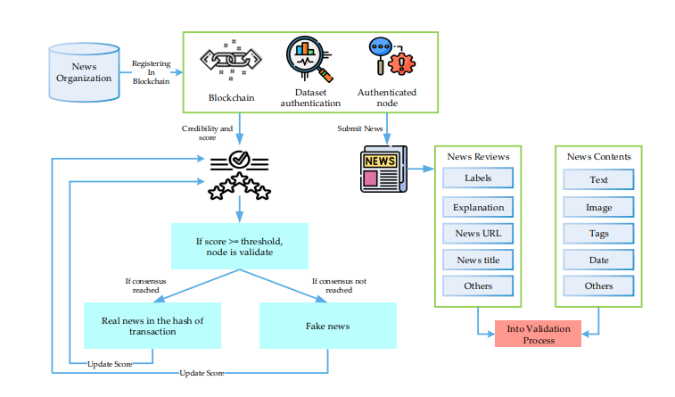

Figure 5. 1 System Architecture

**3-Tier Architecture:**

The three-tier software architecture (a three-layer architecture) emerged in the 1990s to overcome the limitations of the two-tier architecture. The third tier (middle tier server) is between the user interface (client) and the data management (server) components. This middle tier provides process management where business logic and rules are executed and can accommodate hundreds of users (as compared to only 100 users with the two tier architecture) by providing functions such as queuing, application execution, and database staging.

The three tier architecture is used when an effective distributed client/server design is needed that provides (when compared to the two tier) increased performance, flexibility, maintainability, reusability, and scalability, while hiding the complexity of distributed processing from the user. These characteristics have made three layer architectures a popular choice for Internet applications and net-centric information systems.

**Advantages of Three-Tier:**

* Separates functionality from presentation.
* Clear separation – better understanding.
* Changes limited to well define components.
* Can be running on WWW.
* Effective network performance.

**Global Use Case Diagrams:**

**Identification of actors:**

**Actor:** Actor represents the role a user plays with respect to the system. An actor interacts with, but has no control over the use cases.

Graphical representation:

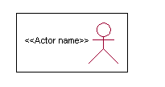

<<Actor name>>

An actor is someone or something that:

Interacts with or uses the system.

* Provides input to and receives information from the system.
* Is external to the system and has no control over the use cases.

**Actors are discovered by examining:**

* Who directly uses the system?
* Who is responsible for maintaining the system?
* External hardware used by the system.
* Other systems that need to interact with the system.

**Questions to identify actors:**

* + Who is using the system? Or, who is affected by the system? Or, which groups need help from the system to perform a task?
  + Who affects the system? Or, which user groups are needed by the system to perform its functions? These functions can be both main functions and secondary functions such as administration.
  + Which external hardware or systems (if any) use the system to perform tasks?
  + What problems does this application solve (that is, for whom)?
  + And, finally, how do users use the system (use case)? What are they doing with the system?

The actors identified in this system are:

1. System Administrator
2. Customer
3. Customer Care

**Identification of use cases:**

Use case: A use case can be described as a specific way of using the system from a user’s (actor’s) perspective.

Graphical representation:



A more detailed description might characterize a use case as:

* Pattern of behavior the system exhibits
* A sequence of related transactions performed by an actor and the system
* Delivering something of value to the actor

Use cases provide a means to:

* capture system requirements
* communicate with the end users and domain experts
* test the system

Use cases are best discovered by examining the actors and defining what the actor will be able to do with the system.

Guide lines for identifying use cases:

* For each actor, find the tasks and functions that the actor should be able to perform or that the system needs the actor to perform. The use case should represent a course of events that leads to clear goal
* Name the use cases.
* Describe the use cases briefly by applying terms with which the user is familiar.

This makes the description less ambiguous

Questions to identify use cases:

* What are the tasks of each actor?
* Will any actor create, store, change, remove or read information in the system?
* What use case will store, change, remove or read this information?
* Will any actor need to inform the system about sudden external changes?
* Does any actor need to inform about certain occurrences in the system?
* What use cases will support and maintains the system?

**Flow of Events**

A flow of events is a sequence of transactions (or events) performed by the system. They typically contain very detailed information, written in terms of what the system should do, not how the system accomplishes the task. Flow of events are created as separate files or documents in your favorite text editor and then attached or linked to a use case using the Files tab of a model element.

A flow of events should include:

* When and how the use case starts and ends
* Use case/actor interactions
* Data needed by the use case
* Normal sequence of events for the use case
* Alternate or exceptional flows

**5.5.1 Construction of Use case diagrams:**

A use case diagram in the Unified Modeling Language (UML) is a type of behavioral diagram defined by and created from a Use-case analysis. Its purpose is to present a graphical overview of the functionality provided by a system in terms of actors, their goals (represented as use cases), and any dependencies between those use cases. The main purpose of a use case diagram is to show what system functions are performed for which actor. Roles of the actors in the system can be depicted.

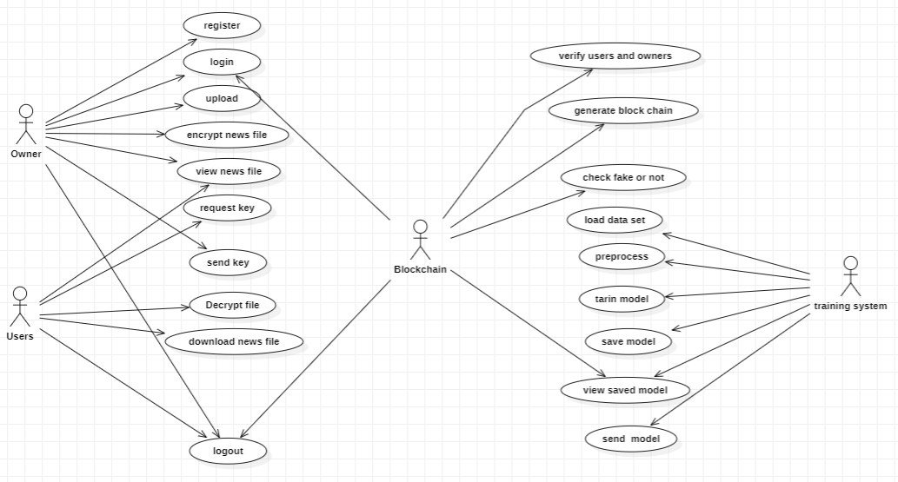

Figure 5. 2 Use Case Diagram

**5.5.2 Sequence Diagrams:**

A sequence diagram in Unified Modeling Language (UML) is a kind of interaction diagram that shows how processes operate with one another and in what order. It is a construct of a Message Sequence Chart. Sequence diagrams are sometimes called event diagrams, event scenarios, and timing diagrams.

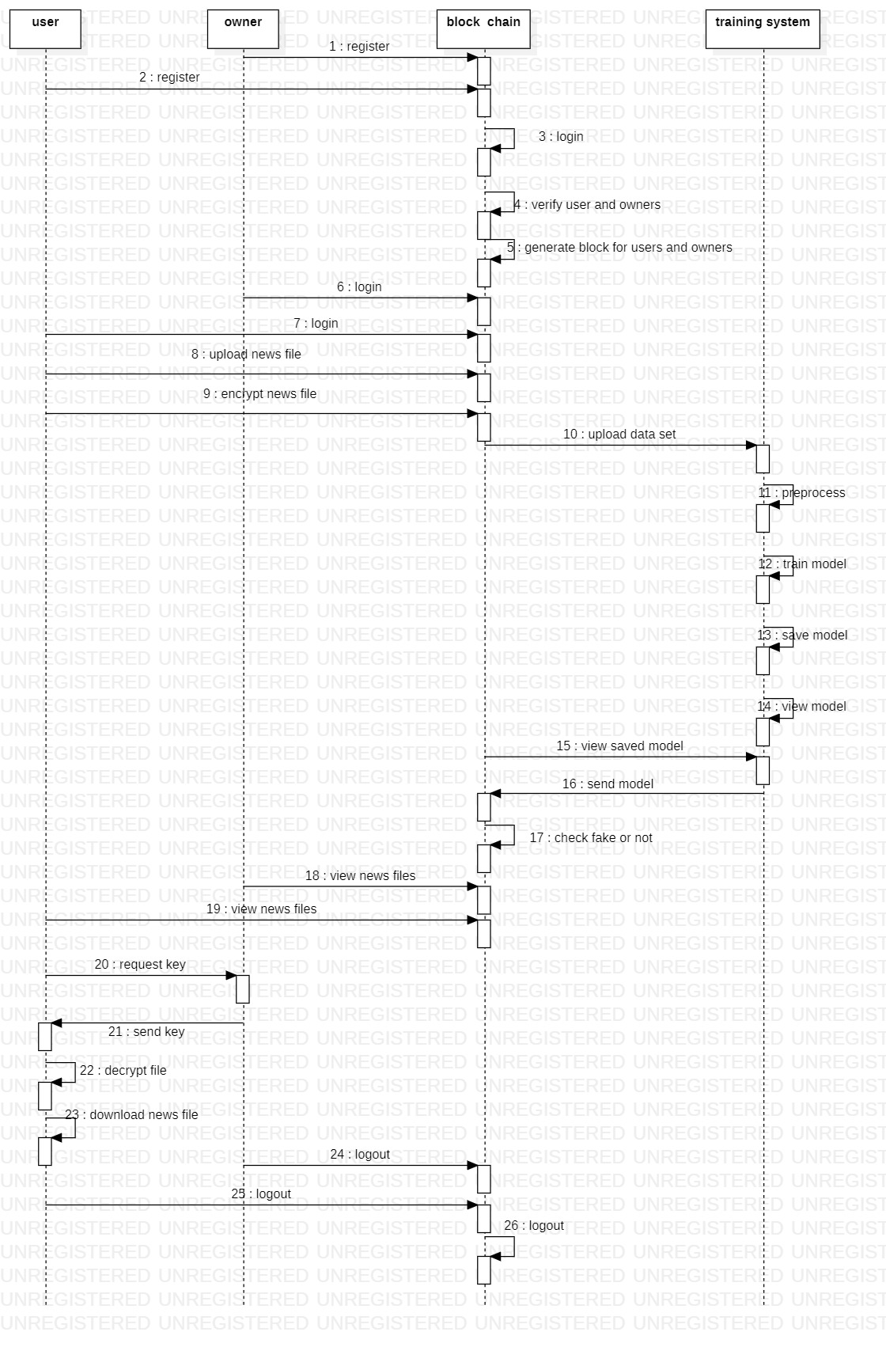

Figure 5. 3 Sequence diagram

**5.5.3 CLASS DIAGRAM:**

In software engineering, a class diagram in the Unified Modeling Language (UML) is a type of static structure diagram that describes the structure of a system by showing the system's classes, their attributes, operations (or methods), and the relationships among the classes. It explains which class contains information.

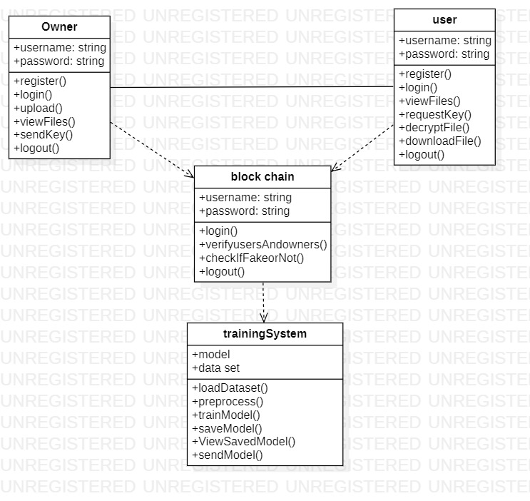

Figure 5. 4 Class Diagram

### 

**5.5.4 ACTIVITY DIAGRAM:**

Activity diagrams are graphical representations of workflows of stepwise activities and actions with support for choice, iteration and concurrency. In the Unified Modeling Language, activity diagrams can be used to describe the business and operational step-by-step workflows of components in a system. An activity diagram shows the overall flow of control.

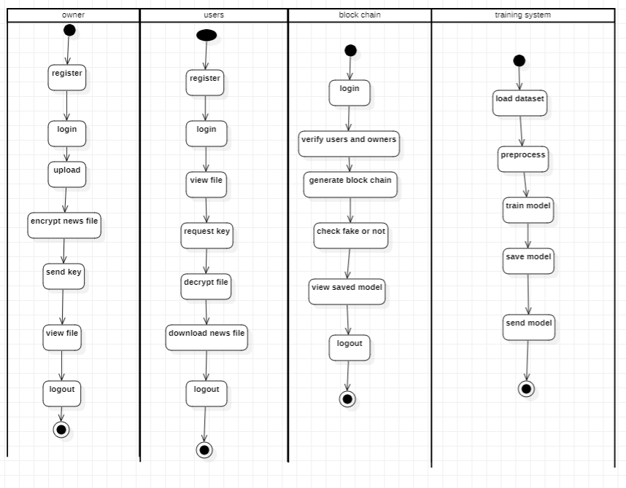

Figure 5. 5 Activity Diagram

# 6. Implementation

**6.1 system requirements**

**HARDWARE REQUIREMENTS**

* System : Intel(R) Core(TM) i3-7020U CPU @ 2.30GHz
* Hard Disk : 1 TB.
* Input Devices : Keyboard, Mouse
* Ram : 4 GB.

**SOFTWARE REQUIREMENTS**

* Operating system : Windows XP/7/10.
* Coding Language : Python
* Tool : Anaconda
* Interface : Flask

To conduct studies and analyses of an operational and technological nature, and To promote the exchange and development of methods and tools for operational analysis as applied to defense problems.

## 6.2 INPUT AND OUTPUT DESIGNS

## 6.2.1 Logical design

The logical design of a system pertains to an abstract representation of the data flows, inputs and outputs of the system. This is often conducted via modeling, using an over-abstract (and sometimes graphical) model of the actual system. In the context of systems design are included. Logical design includes ER Diagrams i.e. Entity Relationship Diagram

**6.2.2 Physical design**

The physical design relates to the actual input and output processes of the system. This is laid down in terms of how data is input into a system, how it is verified / authenticated, how it is processed, and how it is displayed as output. In Physical design, following requirements about the system are decided.

1. Input requirement,
2. Output requirements,
3. Storage requirements,
4. Processing Requirements,
5. System control and backup or recovery.

Put another way, the physical portion of systems design can generally be broken down into three sub-tasks:

1. User Interface Design
2. Data Design
3. Process Design

User Interface Design is concerned with how users add information to the system and with how the system presents information back to them. Data Design is concerned with how the data is represented and stored within the system.

Finally, Process Design is concerned with how data moves through the system, and with how and where it is validated, secured and/or transformed as it flows into, through and out of the system. At the end of the systems design phase, documentation describing the three sub-tasks is produced and made available for use in the next phase.

Physical design, in this context, does not refer to the tangible physical design of an information system. To use an analogy, a personal computer's physical design involves input via a keyboard, processing within the CPU, and output via a monitor, printer, etc. It would not concern the actual layout of the tangible hardware, which for a PC would be a monitor, CPU, motherboard, hard drive, modems, video/graphics cards, USB slots, etc. It involves a detailed design of a user and a product database structure processor and a control processor. The H/S personal specification is developed for the proposed system.

## 6.3 Input & Output representation

## 6.3.1 Input Design

The input design is the link between the information system and the user. It comprises the developing specification and procedures for data preparation and those steps are necessary to put transaction data in to a usable form for processing can be achieved by inspecting the computer to read data from a written or printed document or it can occur by having people keying the data directly into the system. The design of input focuses on controlling the amount of input required, controlling the errors, avoiding delay, avoiding extra steps and keeping the process simple. The input is designed in such a way so that it provides security and ease of use with retaining the privacy. Input Design considered the following things:

* What data should be given as input?
* How the data should be arranged or coded?
* The dialog to guide the operating personnel in providing input.
* Methods for preparing input validations and steps to follow when error occur.

**6.3.2 Objectives**

Input Design is the process of converting a user-oriented description of the input into a computer-based system. This design is important to avoid errors in the data input process and show the correct direction to the management for getting correct information from the computerized system.

It is achieved by creating user-friendly screens for the data entry to handle large volume of data. The goal of designing input is to make data entry easier and to be free from errors. The data entry screen is designed in such a way that all the data manipulates can be performed. It also provides record viewing facilities.

When the data is entered it will check for its validity. Data can be entered with the help of screens. Appropriate messages are provided as when needed so that the user will not be in maize of instant. Thus the objective of input design is to create an input layout that is easy to follow

**6.3.3 Output Design**

A quality output is one, which meets the requirements of the end user and presents the information clearly. In any system results of processing are communicated to the users and to other system through outputs. In output design it is determined how the information is to be displaced for immediate need and also the hard copy output. It is the most important and direct source information to the user. Efficient and intelligent output design improves the system’s relationship to help user decision-making.

* 1. Designing computer output should proceed in an organized, well thought out manner; the right output must be developed while ensuring that each output element is designed so that people will find the system can use easily and effectively. When analysis design computer output, they should Identify the specific output that is needed to meet the requirements.
  2. Select methods for presenting information.
  3. Create document, report, or other formats that contain information produced by the system.

# 7.SAMPLE CODE

# import os

# import MySQLdb

# import smtplib

# import random

# import string

# from datetime import datetime

# from flask import Flask, session, url_for, redirect, render_template, request, abort, flash, send_file

# from database import db_connect,inc_reg,admin_loginact,ins_loginact,vuact

# from database import db_connect,owner_reg,owner_login,cloud_log,aa_log,upload_file,cvf1,ucloud1,uvf1,urequest1,vr3,vr4,vr1,send1,send2,download1,ovf1

# # from cloud import uploadFile,downloadFile,close

# import Crypto.Cipher

# from AES import AESCipher

# import random

# import base64

# import cv2

# from cloud import upload_file_to_drivehq

# from sendmail import sendmail

# from main import generateblockchain

# # def db_connect():

# # _conn = MySQLdb.connect(host="localhost", user="root",

# # passwd="root", db="assigndb")

# # c = _conn.cursor()

# # return c, _conn

# app = Flask(__name__)

# app.secret_key = os.urandom(24)

# @app.route("/")

# def FUN_root():

# return render_template("index.html")

# @app.route("/upload.html")

# def admin():

# return render_template("upload.html")

# @app.route("/ohome.html")

# def ohome():

# return render_template("ohome.html")

# @app.route("/uhome.html")

# def uhome():

# return render_template("uhome.html")

# @app.route("/chome.html")

# def chome():

# return render_template("chome.html")

# @app.route("/ahome.html")

# def ahome():

# return render_template("ahome.html")

# @app.route("/owner.html")

# def owner():

# return render_template("owner.html")

# @app.route("/ownerreg.html")

# def ownerreg():

# return render_template("ownerreg.html")

# @app.route("/cloud.html")

# def cloud():

# return render_template("cloud.html")

# @app.route("/aa.html")

# def aa():

# return render_template("aa.html")

# @app.route("/user.html")

# def ins():

# return render_template("user.html")

# @app.route("/increg.html")

# def increg():

# return render_template("increg.html")

# @app.route("/adminhome.html")

# def adminhome():

# return render_template("adminhome.html")

# @app.route("/ihome.html")

# def ihome():

# return render_template("ihome.html")

# @app.route("/vo.html")

# def vo():

# data = vp()

# print(data)

# return render_template("vo.html",data = data)

# @app.route("/cvf.html")

# def cvf():

# data = cvf1()

# print(data)

# return render_template("cvf.html",data = data)

# @app.route("/ovf.html")

# def ovf():

# data = ovf1()

# print(data) return render_template("ovf.html",data = data)

# @app.route("/vr.html")

# def vr():

# data = vr1()

# print(data)

# return render_template("vr.html",data = data)

# @app.route("/uvf.html")

# def uvf():

# data = uvf1()

# print(data)

# return render_template("uvf.html",data = data)

# @app.route("/download.html")

# def download():

# data = download1()

# print(data)

# return render_template("download.html",data = data)

# @app.route("/vu.html")

# def vu():

# data = vuact()

# print(data)

# return render_template("vu.html",data = data)

# @app.route("/index")

# def index():

# return render_template("index.html")

# @app.route("/ucloud", methods = ['GET','POST'])

# def ucloud():

# b = request.args.get('b')

# d = request.args.get('d')

# g = request.args.get('g')

# file_path = "C:/Users/Mrida/Desktop/upload/"+ b

# username = 'projectsforu'

# password = '1000projects@shan'

# remote_directory = '/cloud'

# upload_file_to_drivehq(file_path, username, password, remote_directory)

# data = ucloud1(b,d)

# return render_template("chome.html")

# @app.route("/urequest", methods = ['GET','POST'])

# def urequest():

# b = request.args.get('b')

# c1 = request.args.get('c')

# f = request.args.get('f')

# g = request.args.get('g')

# i1= request.args.get('h')

# data = urequest1(b,c1,f,g,i1)

# return render_template("uhome.html")

# @app.route("/vr2", methods = ['GET','POST'])

# def vr2():

# b = request.args.get('b')

# c1 = request.args.get('c')

# d = request.args.get('d')

# f = request.args.get('f')

# g = request.args.get('g')

# if c1 == g:

# data1 = vr3(b,d,f)

# data = vr4(d,f)

# return render_template("send.html",data = data)

# else:

# return render_template("chome.html")

# 

# @app.route("/send", methods = ['GET','POST'])

# def send():

# b = request.args.get('b')

# d = request.args.get('d')

# f = request.args.get('f')

# data = send1(b,d,f)

# skey = data[0][0]

# sendmail(skey,f)

# send2(b,d,f)

# return render_template("send.html")

# @app.route("/down1", methods = ['GET','POST'])

# def down1():

# b = request.args.get('b')

# d = request.args.get('d')

# e = request.args.get('e')

# f = request.args.get('f')

# return render_template("d1.html",b=b,d=d,e=e,f=f)

# # @app.route("/uactivate")

# # def uactivate():

# # status = uviewact(request.args.get('a'),request.args.get('b'))

# # data = admin_viewusers()

# # if status == 1:

# # return render_template("viewusers.html",m1="sucess",users=data)

# # else:

# # return render_template("viewusers.html",m1="failed",users=data)

# # -------------------------------Registration-----------------------------------------------------------------

# @app.route("/inceregact", methods = ['GET','POST'])

# def inceregact():

# if request.method == 'POST':

# 

# status = inc_reg(request.form['username'],request.form['password'],request.form['email'],request.form['address'])

# 

# if status == 1:

# return render_template("user.html",m1="sucess")

# else:

# return render_template("increg.html",m1="failed")

# @app.route("/oregact", methods = ['GET','POST'])

# def oregact():

# if request.method == 'POST':

# 

# status = owner_reg(request.form['username'],request.form['password'],request.form['email'],request.form['address'])

# 

# if status == 1:

# return render_template("owner.html",m1="sucess")

# else:

# return render_template("ownerreg.html",m1="failed")

# @app.route("/uploadact", methods = ['GET','POST'])

# def owner_upload():

# if request.method == 'POST':

# file = request.files['file']

# fname = request.form['fname']

# email = session['email']

# data = file.read()

# print(data)

# print(type(data))

# string_data = data.decode('utf-8')

# print(type(string_data))

# AESkey_16 = os.urandom(16)

# aescipher = AESCipher(AESkey_16)

# encodedkey = base64.b64encode(AESkey_16)

# strkey1 = str(encodedkey, 'utf-8')

# aesencrypted = aescipher.encrypt(string_data)

# print('aesEncrypted: %s' % aesencrypted)

# print("encodedAESkey_16: %s" % strkey1)

# print("AESkey_16: %s" % AESkey_16)

# status = upload_file(fname,email,string_data,aesencrypted,strkey1)

# if status == 1:

# return render_template("upload.html",m1="success")

# 

# def save_string_to_file(file_name, file_content):

# with open(file_name, 'w') as file:

# file.write(file_content)

# @app.route("/dact", methods = ['GET','POST'])

# def dact():

# if request.method == 'POST':

# fname = request.form['fname']

# skey = request.form['skey']

# ctext = request.form['ctext']

# decodedkey1 = base64.b64decode(skey)

# aescipherdec = AESCipher(decodedkey1)

# aesdecrypted = aescipherdec.decrypt(ctext)

# print(type(aesdecrypted))

# print('aesDecrypted: %s' % aesdecrypted)

# save_string_to_file(fname, aesdecrypted)

# return render_template("uhome.html",m1="success")

# 

# # #-------------------------------ADD_END---------------------------------------------------------------------------

# # # -------------------------------Loginact-----------------------------------------------------------------

# @app.route("/adminlogact", methods=['GET', 'POST'])

# def adminlogact():

# if request.method == 'POST':

# status = admin_loginact(request.form['username'], request.form['password'])

# print(status)

# if status == 1:

# session['username'] = request.form['username']

# return render_template("adminhome.html", m1="sucess")

# else:

# return render_template("admin.html", m1="Login Failed")

# @app.route("/clogin", methods=['GET', 'POST'])

# def clogin():

# if request.method == 'POST':

# status = cloud_log(request.form['username'], request.form['password'])

# print(status)

# if status == 1:

# session['username'] = request.form['username']

# return render_template("chome.html", m1="sucess")

# else:

# return render_template("cloud.html", m1="Login Failed")

# @app.route("/alogin", methods=['GET', 'POST'])

# def alogin():

# if request.method == 'POST':

# status = aa_log(request.form['username'], request.form['password'])

# print(status)

# if status == 1:

# session['username'] = request.form['username']

# return render_template("ahome.html", m1="sucess")

# else:

# return render_template("aa.html", m1="Login Failed")

# @app.route("/ologin", methods=['GET', 'POST'])

# def ologin():

# if request.method == 'POST':

# status = owner_login(request.form['email'], request.form['password'])

# print(status)

# if status == 1:

# session['email'] = request.form['email']

# return render_template("ohome.html", m1="sucess")

# else:

# return render_template("owner.html", m1="Login Failed")

# @app.route("/inslogin", methods=['GET', 'POST'])

# def inslogin():

# if request.method == 'POST':

# status = ins_loginact(request.form['email'], request.form['password'])

# print(status)

# if status == 1:

# session['email'] = request.form['email']

# return render_template("uhome.html", m1="sucess")

# else:

# return render_template("user.html", m1="Login Failed")

# # # -------------------------------Loginact End-----------------------------------------------------------------

# 

# if __name__ == "__main__":

# app.run(debug=True, host='127.0.0.1', port=5000)

# 8. System Testing

## 8.1 Introduction:

Testing is the debugging program is one of the most critical aspects of the computer programming triggers, without programming that works, the system would never produce an output of which it was designed. Testing is best performed when user development is asked to assist in identifying all errors and bugs. The sample data are used for testing. It is not quantity but quality of the data used the matters of testing. Testing is aimed at ensuring that the system was accurately an efficiently before live operation commands.

**Testing objectives:**

The main objective of testing is to uncover a host of errors, systematically and with minimum effort and time. Stating formally, we can say, testing is a process of executing a program with intent of finding an error.

1. A successful test is one that uncovers an as yet undiscovered error.
2. A good test case is one that has probability of finding an error, if it exists.
3. The test is inadequate to detect possibly present errors.
4. The software more or less confirms to the quality and reliable standards.

## 8.2 Levels of Testing

**Code testing:**

This examines the logic of the program. For example, the logic for updating various sample data and with the sample files and directories were tested and verified.

**Specification Testing:**

Executing this specification starting what the program should do and how it should performed under various conditions. Test cases for various situation and combination of conditions in all the modules are tested.

**Unit testing:**

In the unit testing we test each module individually and integrate with the overall system. Unit testing focuses verification efforts on the smallest unit of software design in the module. This is also known as module testing. The module of the system is tested separately. This testing is carried out during programming stage itself. In the testing step each module is found to work satisfactorily as regard to expected output from the module.

There are some validation checks for fields also. For example the validation check is done for varying the user input given by the user which validity of the data entered. It is very easy to find error debut the system.

Each Module can be tested using the following two Strategies:

1. Black Box Testing
2. White Box Testing

**Black Box Testing**

What is Black Box Testing?

Black box testing is a software testing techniques in which functionality of the software under test (SUT) is tested without looking at the internal code structure, implementation details and knowledge of internal paths of the software. This type of testing is based entirely on the software requirements and specifications.

In Black Box Testing we just focus on inputs and output of the software system without bothering about internal knowledge of the software program.

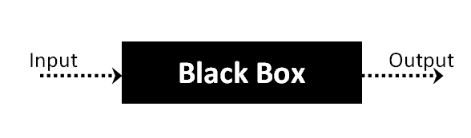

The above Black Box can be any software system you want to test. For example : an operating system like Windows, a website like Google ,a database like Oracle or even your own custom application. Under Black Box Testing , you can test these applications by just focusing on the inputs and outputs without knowing their internal code implementation.

**Black box testing - Steps**

Here are the generic steps followed to carry out any type of Black Box Testing.

* Initially requirements and specifications of the system are examined.
* Tester chooses valid inputs (positive test scenario) to check whether SUT processes them correctly. Also some invalid inputs (negative test scenario) are chosen to verify that the SUT is able to detect them.
* Tester determines expected outputs for all those inputs.
* Software tester constructs test cases with the selected inputs.
* The test cases are executed.
* Software tester compares the actual outputs with the expected outputs.
* Defects if any are fixed and re-tested.

**Types of Black Box Testing**

There are many types of Black Box Testing but following are the prominent ones -

* Functional testing – This black box testing type is related to functional requirements of a system; it is done by software testers.
* Non-functional testing – This type of black box testing is not related to testing of a specific functionality, but non-functional requirements  such as performance, scalability, usability.
* Regression testing – Regression testing is done  after code fixes , upgrades or any other system maintenance to check the new code has not affected the existing code.

**White box testing**

White Box Testing is the testing of a software solution's internal coding and infrastructure. It focuses primarily on strengthening security, the flow of inputs and outputs through the application, and improving design and usability.White box testing is also known as clear, open, structural, and glass box testing.

It is one of two parts of the "box testing" approach of software testing. Its counter-part, blackbox testing, involves testing from an external or end-user type perspective. On the other hand, Whitebox testing is based on the inner workings of an application and revolves around internal testing. The term "whitebox" was used because of the see-through box concept. The clear box or whitebox name symbolizes the ability to see through the software's outer shell (or "box") into its inner workings. Likewise, the "black box" in "black box testing" symbolizes not being able to see the inner workings of the software so that only the end-user experience can be tested

WHAT DO YOU VERIFY IN WHITE BOX TESTING?

White box testing involves the testing of the software code for the following:

* Internal security holes
* Broken or poorly structured paths in the coding processes
* The flow of specific inputs through the code
* Expected output
* The functionality of conditional loops
* Testing of each statement, object and function on an individual basis

The testing can be done at system, integration and unit levels of software development. One of the basic goals of whitebox testing is to verify a working flow for an application. It involves testing a series of predefined inputs against expected or desired outputs so that when a specific input does not result in the expected output, you have encountered a bug.

HOW DO YOU PERFORM WHITE BOX TESTING?

  To give you a simplified explanation of white box testing, we have divided it into **two basic steps**. This is what testers do when testing an application using the white box testing technique:

**STEP 1) UNDERSTAND THE SOURCE CODE**

The first thing a tester will often do is learn and understand the source code of the application. Since white box testing involves the testing of the inner workings of an application, the tester must be very knowledgeable in the programming languages used in the applications they are testing. Also, the testing person must be highly aware of secure coding practices. Security is often one of the primary objectives of testing software. The tester should be able to find security issues and prevent attacks from hackers and naive users who might inject malicious code into the application either knowingly or unknowingly.

**STEP 2) CREATE TEST CASES AND EXECUTE**

The second basic step to white box testing involves testing the application’s source code for proper flow and structure. One way is by writing more code to test the application’s source code. The tester will develop little tests for each process or series of processes in the application. This  method requires that the tester must have intimate knowledge of the code and is often done by the developer. Other methods include manual testing, trial and error testing and the use of testing tools as we will explain further on in this article.

**Unit Testing**

|  |  |
| --- | --- |
| Sl # Test Case : ­ | UTC­1 |
| Name of Test: ­ | Data Set Feature Label Extraction |
| Items being tested: ­ | Features and Labels are extracted or not |
| Sample Input: ­ | Csv files vitamin dataset and food recommendation dataset |
| Expected output: ­ | Features copied to x labels to y |
| Actual output: ­ | Data with features and labels are displayed. |
| **Remarks: ­** | **Pass.** |

|  |  |
| --- | --- |
| Sl # Test Case : ­ | UTC­2 |
| Name of Test: ­ | Register login |
| Items being tested: ­ | User registration details stored in Database and login success or Fail |
| Sample Input: ­ | Username, password, email, phone number, address |
| Expected output: ­ | Registration successful, login success |
| Actual output: ­ | Details stored in database and verification is success for correct details |

**Integration Testing:**

Integration testing is a level of software testing where individual units are combined and tested as a group. The purpose of this level of testing is to expose faults in the interaction between integrated units. Test drivers and test stubs are used to assist in Integration Testing. Integration testing is defined as the testing of combined parts of an application to determine if they function correctly. It occurs after unit testing and before validation testing. Integration testing can be done in two ways: Bottom­up integration testing and Top­down integration testing.

**Bottom­up Integration**

This testing begins with unit testing, followed by tests of progressively higher­level combinations of units called modules or builds.

**Top­down Integration**

In this testing, the highest­level modules are tested first and progressively, lower­level modules are tested thereafter.

In a comprehensive software development environment, bottom­up testing is usually done first, followed by top­down testing. The process concludes with multiple tests of the complete application, preferably in scenarios designed to mimic actual situations. Table 6.5 shows the test cases for integration testing and their results

|  |  |
| --- | --- |
| Sl # Test Case : ­ | ITC­1 |
| Name of Test: ­ | Input values |
| Item being tested: ­ | It is Fraud crypto or not predicted |
| Sample Input: ­ | 844.26 1093.71 721 89 810 865.6910932 586.4666748 |
| Expected output: ­ | Normal transaction |
| Actual output: ­ | Normal transaction |
| Remarks: ­ | Pass. |

**System Testing:**

System testing of software or hardware is testing conducted on a complete, integrated system to evaluate the system's compliance with its specified requirements. System testing falls within the scope of black­box testing, and as such, should require no knowledge of the inner design of the code or logic. System testing is important because of the following reasons:System testing is the first step in the Software Development Life Cycle, where the application is tested as a whole.

The application is tested thoroughly to verify that it meets the functional and technical specifications.

The application is tested in an environment that is very close to the production environment where the application will be deployed.

System testing enables us to test, verify, and validate both the business requirements as well as the application architecture.

System Testing is shown in below tables

|  |  |
| --- | --- |
| Sl # Test Case : ­ | STC­1 |
| Name of Test: ­ | System testing in various versions of OS |
| Item being tested: ­ | OS compatibility. |
| Sample Input: ­ | Execute the program in windows XP/ Windows­7/8 |
| Expected output: ­ | Performance is better in windows­7 |
| Actual output: ­ | Same as expected output, performance is better in windows­7 |
| Remarks: ­ | Pass |

**Test Cases**

|  |  |  |  |  |
| --- | --- | --- | --- | --- |
| **S.NO** | **Message** | **Expected**  **Outcome** | **Actual**  **Outcome** | **status** |
| **1** | Social media post containing verifiable false information | **Fake** | **Fake** | **Pass** |
| **2** | Video clip spreading misinformation about a public health issue | **Real** | **Real** | **Pass** |
| **3** | Image meme with manipulated content designed to deceive | **Real** | **Fake** | **Fail** |
| **4** | Real-time social media stream with rapidly evolving misinformation trends | **Fake** | **Fake** | **Pass** |

**9.Declaration of Results**

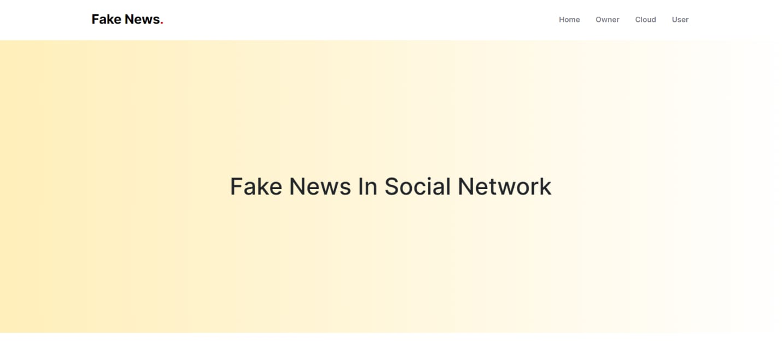

**Fig 9.1** This is the initial interface of the website

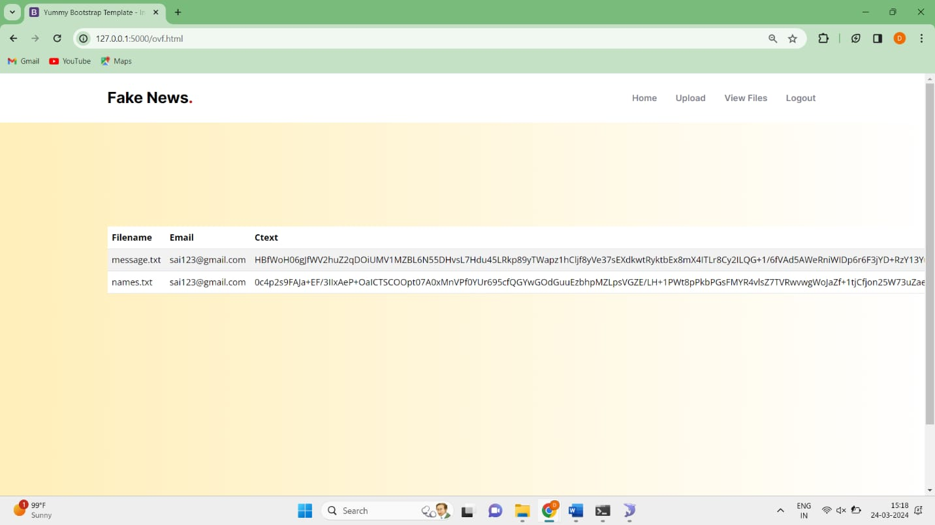

**Fig 9.2** This represents the exsisting fies in the format of cipher text

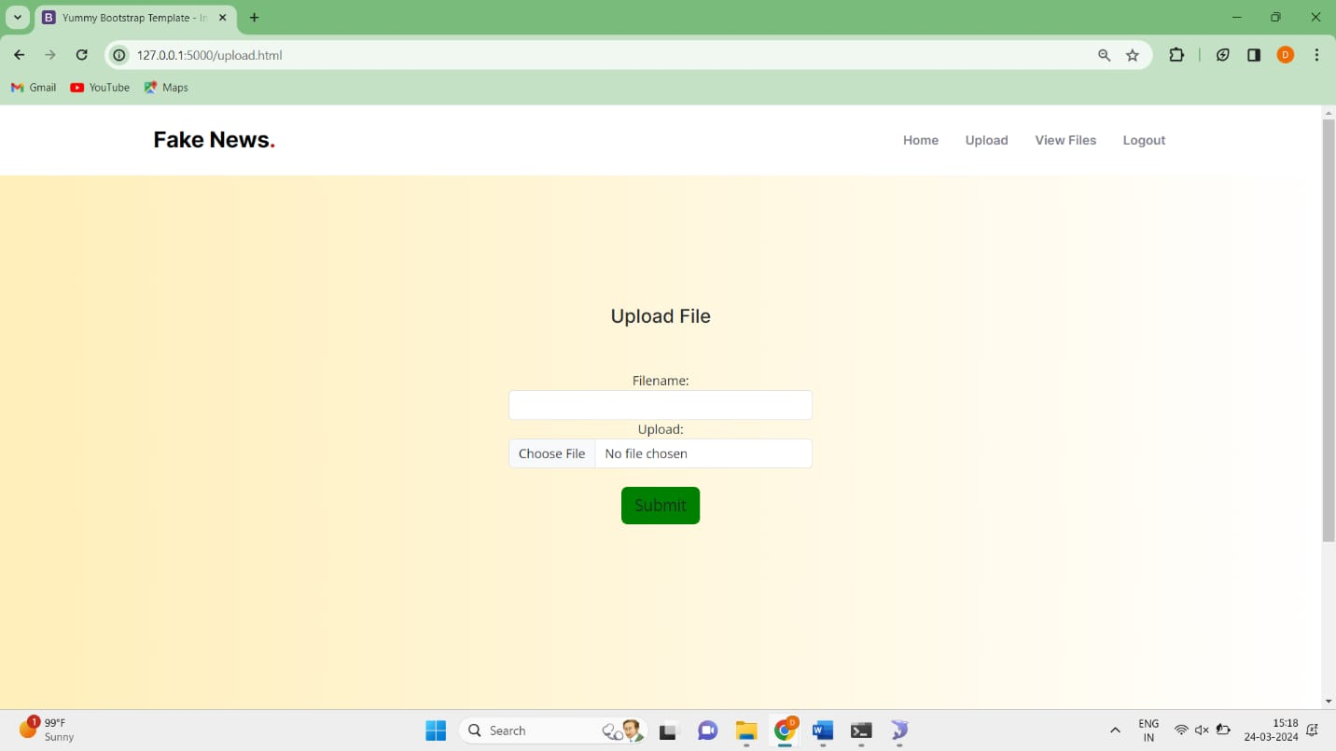

**Fig 9.3** It is the interface to upload the text file

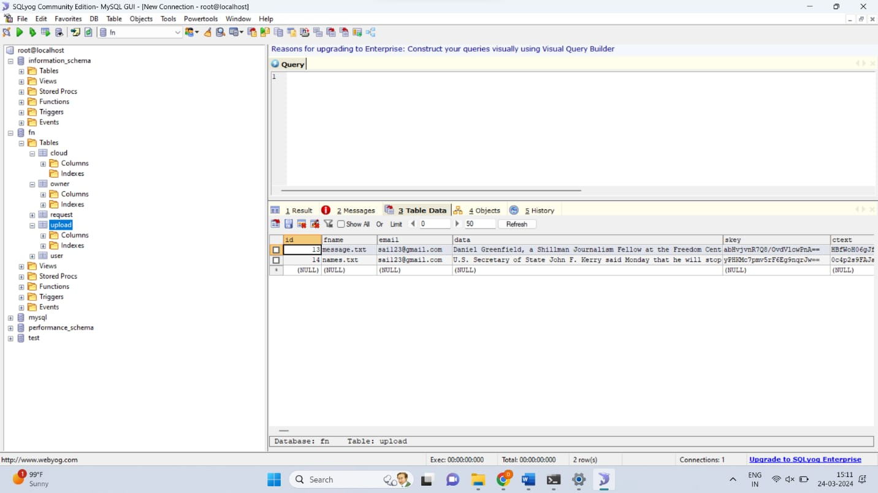

**Fig 9.4** Backend process of Storing the Credentials

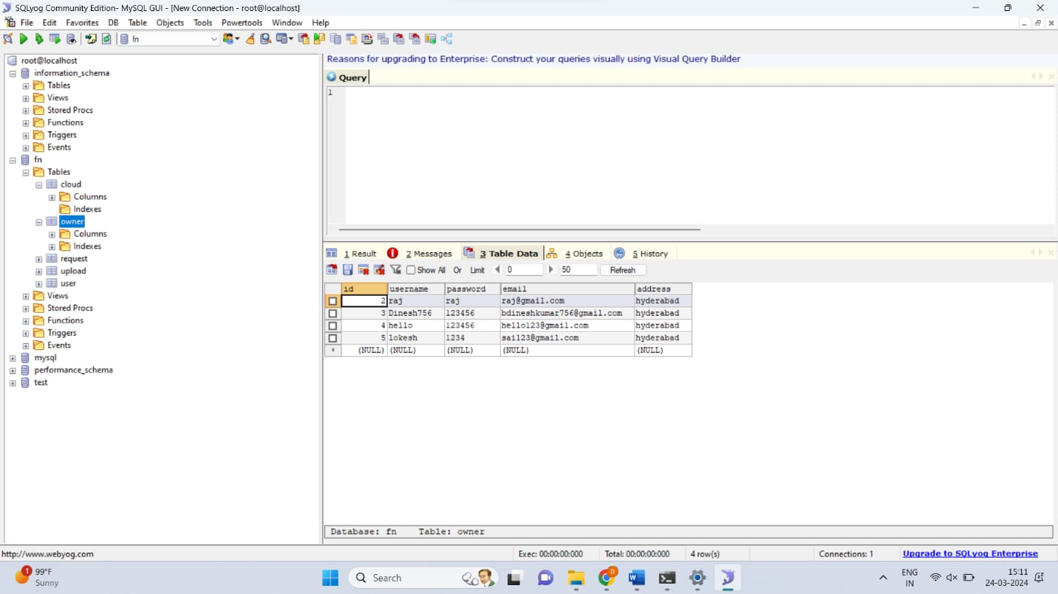

**Fig 9.5** User and Owner Details



**Fig 9.6** New user Registration page

**10. Conclusion**

Fake news sharing is one of the popular research problems in recent technology based on lack of security and trust in terms of the truth of shared news in social media. It presents the combination of blockchain and machine learning techniques to provide solutions and design a trust-based architecture toward shared news online. Applied the reinforcement learning technique, a learning-based algorithm, to make a strong decision-making architecture and combine it with blockchain framework, smart contract, and customized consensus algorithm, which is well fit for the Proof-of-Authority protocol. Social media plays a key role in this process. The shared information platform contains fake news, and its a beneficial challenge to enhance and investigate the Proof-of-Authority protocol and user validation.

**11.Future Scope**

The project of fake news detection using cloud computing presents a rich landscape for future exploration and innovation. As misinformation continues to pose significant challenges in the digital age, advancements in detection methodologies leveraging cloud infrastructure hold promise for addressing this pressing issue. In this discussion, we will delve into several key areas of future scope for the project, exploring potential advancements in detection models, adaptive algorithms, multilingual analysis, ethical considerations, collaborative frameworks, and societal impacts.

**Advancements in Detection Models:**

One promising avenue for future research involves enhancing the accuracy and robustness of fake news detection models. While existing approaches have made significant strides, there remains room for improvement in model performance. Researchers can explore the development of more sophisticated machine learning algorithms, including deep learning architectures tailored specifically for fake news detection. These advanced models can leverage the rich contextual information present in textual, visual, and multimedia content to discern patterns of misinformation with greater precision. Additionally, incorporating ensemble learning techniques that combine multiple models or leveraging transfer learning from related tasks could further enhance detection capabilities.

**Adaptive Algorithms for Dynamic Detection:**

Fake news tactics are constantly evolving, requiring detection systems that can adapt to new trends and emerging threats in real-time. Future research could focus on developing adaptive algorithms capable of learning and evolving over time. These algorithms could continuously update their detection strategies based on feedback from users and evolving patterns of misinformation. By leveraging techniques such as reinforcement learning or online learning, these adaptive algorithms can stay ahead of malicious actors and effectively combat the spread of fake news across online platforms.

**Multilingual and Cross-cultural Analysis:**

Fake news is not confined to any single language or cultural context, making multilingual and cross-cultural analysis essential for effective detection. Future research can explore methods for developing detection models that can analyze content in multiple languages and cultural contexts. This entails addressing linguistic nuances, cultural sensitivities, and regional variations in the dissemination of misinformation. By incorporating techniques such as machine translation, cross-lingual transfer learning, and sentiment analysis in diverse languages, detection systems can achieve greater coverage and accuracy in identifying fake news across global online communities.

**Ethical Considerations in Detection:**

As fake news detection technologies become more prevalent, it is imperative to consider the ethical implications of their deployment. Future research should address concerns related to user privacy, algorithmic biases, and potential impacts on freedom of expression. Privacy-preserving techniques such as differential privacy, federated learning, and homomorphic encryption can safeguard user data while enabling effective detection. Moreover, researchers must strive to mitigate algorithmic biases by ensuring diversity and representativeness in training datasets and transparency in model decision-making processes. Additionally, ethical guidelines and regulatory frameworks should be developed to govern the responsible use of fake news detection technologies and protect users' rights and freedoms.

**Collaborative Frameworks for Knowledge Sharing:**

Effective collaboration between researchers, industry stakeholders, and policymakers is essential for addressing the complex challenges of fake news detection. Future research could focus on developing collaborative frameworks and platforms that facilitate knowledge sharing, data sharing, and coordination among various stakeholders involved in combating misinformation. These platforms could serve as hubs for sharing insights, best practices, and datasets, fostering interdisciplinary collaboration and collective action in the fight against fake news. By bringing together diverse expertise and resources, collaborative frameworks can accelerate innovation and drive meaningful impact in mitigating the spread of misinformation online.

**Societal Impacts and Long-term Considerations:**

Beyond technological advancements, it is crucial to consider the broader societal impacts of fake news detection efforts. Future research should examine the potential implications of detection technologies on public discourse, media literacy, and democratic processes. While fake news detection plays a vital role in safeguarding the integrity of online information ecosystems, it is not a panacea for addressing the underlying drivers of misinformation. Researchers must consider the socio-political context in which detection technologies are deployed and strive to promote transparency, accountability, and informed public debate. Moreover, long-term studies are needed to assess the effectiveness and unintended consequences of fake news detection interventions, ensuring that they align with broader societal goals of promoting truth, trust, and civic engagement in the digital age.

**12.References**

[1] Vladimir P Miletskiy, Dmitry N Cherezov, and Elena V Strogetskaya. Transformations of professional political communications in the digital society (by the example of the fake news communication strategy). In 2019 Communication Strategies in Digital Society Workshop (ComSDS), pages 121–124. IEEE, 2019.

[2] Nicollas R de Oliveira, Dianne SV Medeiros, and Diogo MF Mattos. A sensitive stylistic approach to identify fake news on social networking. IEEE Signal Processing Letters, 27:1250–1254, 2020.

[3] Guanfeng Liu, Yan Wang, and Mehmet Orgun. Optimal social trust path selection in complex social networks. In Proceedings of the AAAI Conference on Artificial Intelligence, volume 24, 2010.

[4] Maria Nefeli Nikiforos, Spiridon Vergis, Andreana Stylidou, Nikolaos Augoustis, Katia Lida Kermanidis, and Manolis Maragoudakis. Fake news detection regarding the hong kong events from tweets. In IFIP international Conference on Artificial Intelligence Applications and Innovations, pages 177–186. Springer, 2020.

[5] Adline Rajasenah Merryton and Gethsiyal Augasta. A survey on recent advances in machine learning techniques for fake news detection. Test Eng. Manag, 83:11572–11582, 2020.

[6] Xishuang Dong, Uboho Victor, Shanta Chowdhury, and Lijun Qian. Deep two-path semi-supervised learning for fake news detection. arXiv preprint arXiv:1906.05659, 2019.

[7] Sachin Kumar, Rohan Asthana, Shashwat Upadhyay, Nidhi Upreti, and Mohammad Akbar. Fake news detection using deep learning models: A novel approach. Transactions on Emerging Telecommunications Technologies, 31(2):e3767, 2020.

[8] Pritika Bahad, Preeti Saxena, and Raj Kamal. Fake news detection using bi-directional lstm-recurrent neural network. Procedia Computer Science, 165:74–82, 2019.

[9] Giuseppe Sansonetti, Fabio Gasparetti, Giuseppe D’aniello, and Alessandro Micarelli. Unreliable users detection in social media: Deep learning techniques for automatic detection. IEEE Access, 8:213154–213167, 2020.

[10] Mohammad Mahyoob, Jeehaan Al-Garaady, and Musaad Alrahaili. Linguistic-based detection of fake news in social media. Forthcoming, International Journal of English Linguistics, 11(1), 2020.

[11] Abhishek Koirala. Covid-19 fake news classification using deep learning. 2020.

[12] Hyungjin Gill and Hernando Rojas. Chatting in a mobile chamber: effects of instant messenger use on tolerance toward political misinformation among south koreans. Asian Journal of Communication, 30(6):470–493, 2020.

[13] Jairo L Alves, Leila Weitzel, Paulo Quaresma, Carlos E Cardoso, and Luan Cunha. Brazilian presidential elections in the era of misinformation: A machine learning approach to analyse fake news. In Iberoamerican Congress on Pattern Recognition, pages 72–84. Springer, 2019.

[14] Nicollas R de Oliveira, Pedro S Pisa, Martin Andreoni Lopez, Dianne Scherly V de Medeiros, and Diogo MF Mattos. Identifying fake news on social networks based on natural language processing: Trends and challenges. Information, 12(1):38, 2021.

[15] Despoina Mouratidis, Maria Nefeli Nikiforos, and Katia Lida Kermanidis. Deep learning for fake news detection in a pairwise textual input schema. Computation, 9(2):20, 2021.

[16] Arvind Narayanan, Joseph Bonneau, Edward Felten, Andrew Miller, and Steven Goldfeder. Bitcoin and cryptocurrency technologies: a comprehensive introduction. Princeton University Press, 2016.

[17] Rohit Raturi. Machine learning implementation for business development in real time sector. International Journal of Pure and Applied Mathematics, 119(15):1289–1300, 2018.

[18] Bing Liu, Qingbo Zhao, Yueqiang Jin, Jiayu Shen, and Chaoyang Li. Application of combined model of stepwise regression analysis and artificial neural network in data calibration of miniature air quality detector. Scientific Reports, 11(1):1–12, 2021.

[19] Adam Karbowski. A note on patents and leniency. Gospodarka Narodowa, 301(1):97–108, 2020.

[20] J Antony Vijay, H Anwar Basha, and J Arun Nehru. A dynamic approach for detecting the fake news using random forest classifier and nlp. In Computational Methods and Data Engineering, pages 331–341. Springer, 2021.